# 4CS 340 Liam Nunes Project 2 README

## About the Project/Project Title

This project is a database sorting application that allows the user to search through an animal shelter database based of of certain search criteria based off of different service animals that the user might be searching for.

## Motivation

This project was created for Grazioso Salvare, a company specializing in training service animals, in order to better search the local animal for potential animals that are a match for the criteria of different types of service animals.

## Getting Started

The first step to getting started is to download the AAC database using the MongoDB import tool as show below.

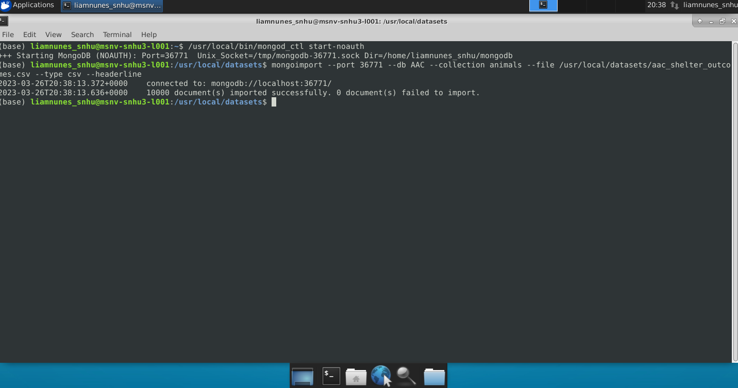

## Installation

You will need MongoDB installed(found at: <https://www.mongodb.com/docs/manual/installation/>) and jupyter notebook installed(found at: <https://jupyter.org/install>)

Additionally you will need the AnimalShelterCRUD.py file included

## Usage

The first step is to load the database and the CRUD manager with the proper username and password

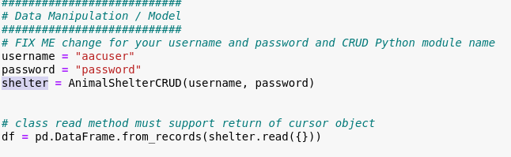

Next is to create the layout of the screen: the first step of that is to load the logo given by Grazioso Salvare and put that image in with your digital signature

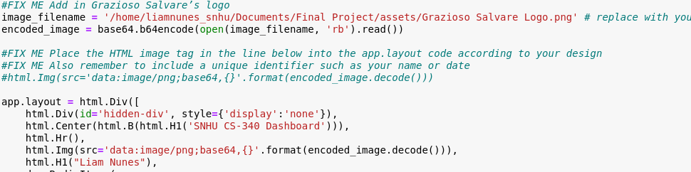

Then you need to create the radio button that allow the user to select the different filtering options and the data table that the user can interact with

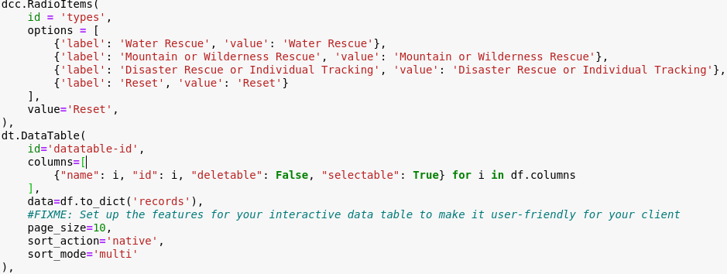

Lastly for the display you need to set up the map and pie chart so they will display side by side

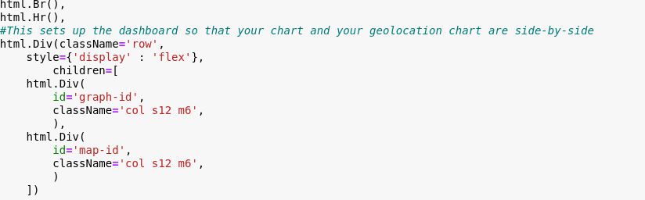

To implement the radio buttons functionality you nee to set up the update dashboard so that it reads the value of the selected button then executed the CRUD read command with the specifications:

The Water rescue looks like this:

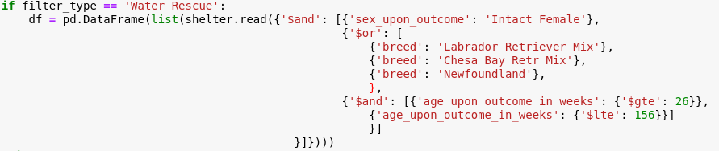

The Mountain or wilderness rescue looks like this:

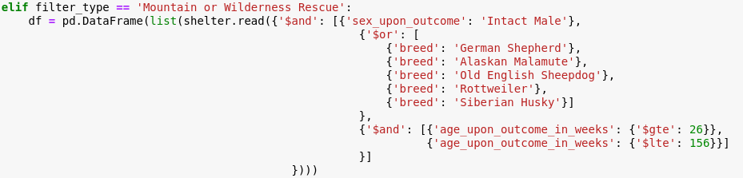

the Disaster rescue or individual tracking looks like this:

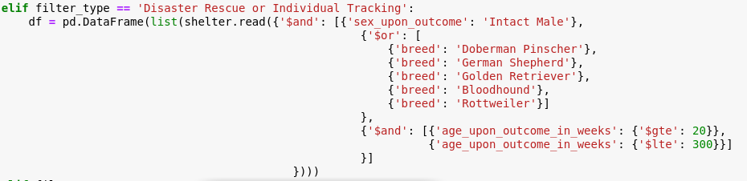

and the reset read command to reset the table looks like this:

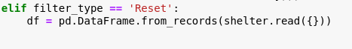

then to make the pie chart you do this:

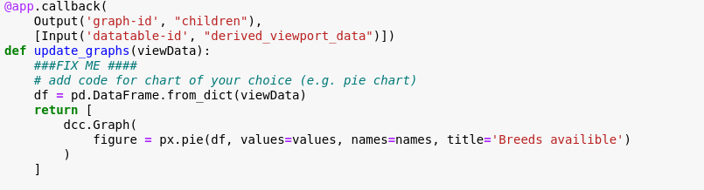

and finally to make the map you implement this:

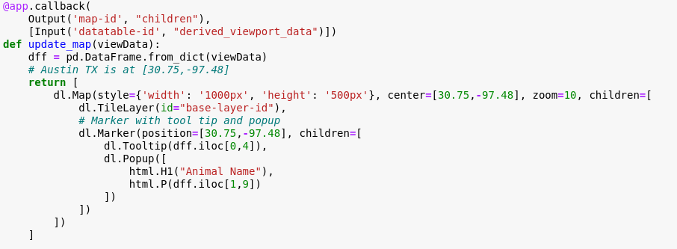

The output results (note this is without the update dashboard as with that in there nothing was displaying so the functionality for the radio buttons are not working and from some reason the pie chart is also not displaying at all):

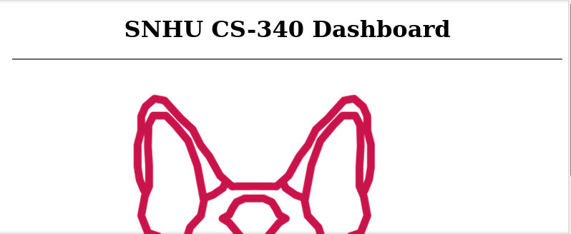

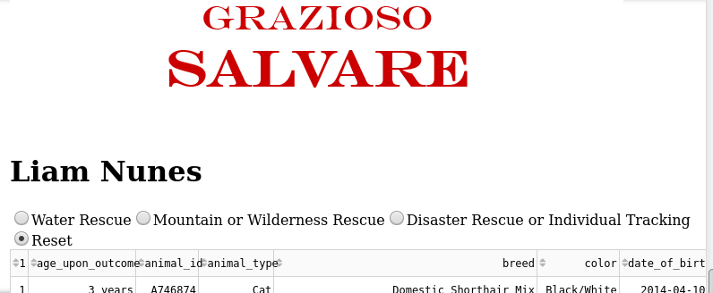

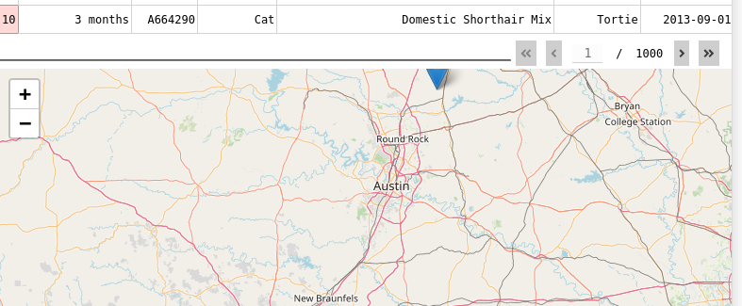

## Roadmap (Optional)

There are 2 features that currently are not working. The first is when I include the Update Dashboard to set the functionality for the radio button the display stops displaying anything at all making testing impossible, so I need to fix the implementation of that. The second feature is that it is not displaying the pie chart next to the map like it is supposed to.

## Contact

Liam Nunes